1: First Palindromic String in an Array and find its completity

n = int(input("Enter number of strings: "))
arr = []

for i in range(n):
arr.append(input("Enter string: "))

found = False

for s in arr:
if s == s[::-1]:
print("First Palindromic String:", s)
found = True
break

if not found:
print("No Palindromic String found")

Output
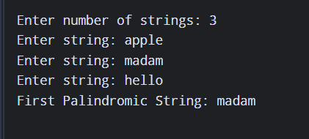

2: Common Elements Between Two Arrays and find its completity

n = int(input("Enter size of first array: "))
a = []

for i in range(n):
a.append(int(input("Enter element: ")))

m = int(input("Enter size of second array: "))
b = []

for i in range(m):
b.append(int(input("Enter element: ")))

common = []

for x in a:
if x in b and x not in common:
common.append(x)

print("Common Elements:", common)

Output
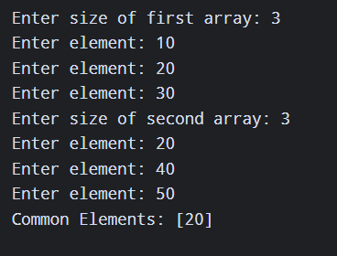

3: Subarrays Distinct Element Sum of Squares

n = int(input("Enter size of array: "))
arr = []

for i in range(n):
arr.append(int(input("Enter element: ")))

total = 0

for i in range(n):
distinct = set()

for j in range(i, n):
distinct.add(arr[j])

for x in distinct:
total += x * x

print("Sum of Squares:", total)

Output
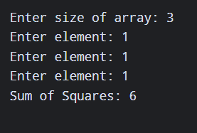

4: Count Equal and Divisible Pairs in an Array

n = int(input("Enter size of array: "))
arr = []

for i in range(n):
arr.append(int(input("Enter element: ")))

count = 0

for i in range(n):
for j in range(i + 1, n):
if arr[i] == arr[j] and (i * j) % 2 == 0:
count += 1

print("Number of equal and divisible pairs:", count)

Output
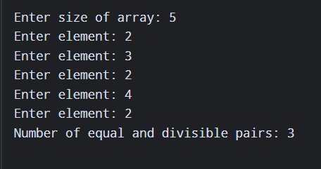
5: Maximum Element with Least Time Complexity

n = int(input("Enter size of array: "))
arr = []

for i in range(n):
arr.append(int(input("Enter element: ")))

maximum = arr[0]

for i in range(1, n):
if arr[i] > maximum:
maximum = arr[i]

print("Maximum Element:", maximum)

Output
